|  |
| --- |
| Team 1 |
| Reliable Message |
| Research Work |
|  |
| Pragati Bharadwaja |
| Feng Yan |
| Shree Ramakrishnan |
| **11/14/2011** |

|  |
| --- |
| This document discuss on achieving reliability independent of transport layers used between two endpoints. This document also discusses features of reliable session provided as part of WCF and support towards transport layers. |

**Reliable Messaging**

**Problem:**

Internet is vast with many possible different connections between two nodes. With the advent of applications getting integrated frequently, achieving reliability over HTTP transport protocol by the heterogeneous applications has become a necessity. The inherent lack of transport reliability of HTTP is very problematic for reasons as follows:

* Transport level failures
* Message level failures
* Sequence of delivery

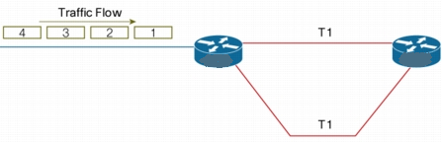

**Figure 1:** Messages sent in order from Sender

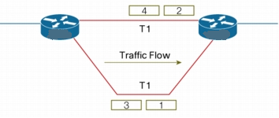

**Figure 2:** Messages traversing through different network

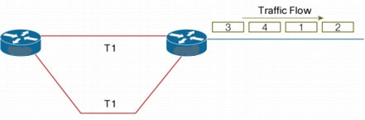

**Figure 3:** Packets arriving out of sequence at Receiver

**Solution:**

The transport-independent WS-Reliable Messaging (or WS-RM) protocol allows for creating reliable communication paths over unreliable connections and protocols. It does so by establishing end-to-end communication sessions and by introducing explicit acknowledgement of messages into the communication flow.

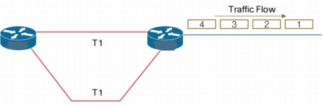

**Figure 4:** After reliable messaging, messages arriving in sequence at Receiver

A reliable session provides for SOAP messages. The reliable channel provides reliable transfer as follows:

* At the SOAP message level
* As transport-neutral.
* The reliable session is between the sender and receiver SOAP endpoints, regardless of the number of transport connections required for connectivity between them.

**Working:**

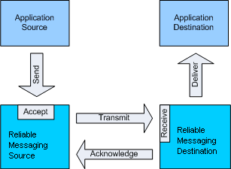

**Figure 5:** Message flow between two end points

A client sends a sequence of messages across a communication link and asks the receiver to acknowledge that it has received the message(s).

The acknowledgement(s) are sent back to the client and once the client has received the acknowledgement, it knows that the message(s) has been successfully transferred.

WS-Reliable Messaging works similar to TCP protocol. It works independent of the underlying transport. WS-RM is designed to control reliable delivery of single SOAP messages or sequences of SOAP messages between two endpoints, irrespective of how these endpoints are connected; for instance even if messages travel through message routers or other intermediaries using different transport protocols for each of hop.

Reliable messaging requires "session" and messages sent in the context of session is assigned a unique number denoting its order in the sequence. The sender-side establishes a temporary cache to keep track of the messages sent and matches them up with the incoming acknowledgements. If a message is not acknowledged after a certain time, the message is resent automatically from the cache. Once an acknowledgement is received, the message is removed from the cache.

The receiver-side establishes a cache for holding messages it accepted in order to store them before delivering them to the application.

WS-RM is supported by a binding element named "reliable session" where session support and reliable messaging support each other.

**Additional Features:**

* **Caching**

This serves to temporarily hold any messages received out-of-order so that messages can be delivered to the application in the order they were sent. This happens if the application requires ordered delivery and message order enforcement is turned on.

* **Auto Acknowledgement**

The RM channel pulls the messages out of the underlying transport queue as they arrive, sends out the necessary acknowledgements and keeps the messages available in its own queue to be picked up by the service model layer.

* **Duplicate message detection**

In addition for supporting ordered delivery, the message number allows the receiver-side to detect duplicate messages and discard them. Messages can be duplicated on the path from the sender to the receiver, or be sent twice by the sender-side if an acknowledgment is lost or delayed.

**Supported Protocols:**

* HTTP-based transport standard bindings:
  + **WsHttpBinding** and expose request-reply or one-way contracts.
  + Can be used when using reliable session over a request-reply or simple one-way service contract.
  + **WsDualHttpBinding** and expose duplex, request-reply, or one-way contracts.
  + **WsFederationHttpBinding** and expose request-reply or one-way contracts.
* TCP-based transport standard bindings:
  + **NetTcpBinding** and expose duplex, request reply, or one-way contracts.

**Usages:**

WS-RM is most appropriate in the following context, though above mentioned protocols are supported.

* SOAP intermediaries, such as SOAP routers
* Proxy intermediaries or transport bridges.
* Intermittent connectivity.
* Sessions over HTTP.

**References:**

<http://msdn.microsoft.com/en-us/library/aa480191.aspx>

<http://msdn.microsoft.com/en-us/library/hh128101(v=prot.13).aspx>

<http://msdn.microsoft.com/en-us/library/cc219293.aspx>

<http://en.wikipedia.org/wiki/WS-ReliableMessaging>

<http://msdn.microsoft.com/en-us/library/ms733136.aspx>